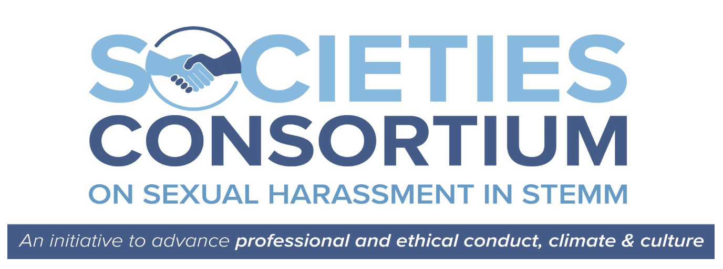

CASE STUDY LIBRARY

Case Study 2. Power and Picnics Don’t Mix

Case Study 2 addresses: “incident(s) involving people who bring money and prestige to an institution, e.g., a person that becomes “too big to fail.”
A male tenured professor and society board member has brought in significant research funding and greatly enhanced the prestige of a university as an-up-and-coming program for women interested in computer science careers. He also writes and publishes historic-romance graphic novels, under a pen name, in his free time. The professor pressures his Black female graduate assistant/advisee to read one of his books, which has a racist and sexualized title and content, and discuss it at a picnic lunch. Despite the student raising her concerns with another faculty member in the department, when she meets her advisor for the picnic, he attempts to kiss and grope her.

Case Study 2. Volume II

- Facts and Scopes of Issues
- Facilitator Guide: Reflections
- Facilitator Guide: Analysis

Overview – Facilitator Guide: Reflections
This guide, which provides “pause & process” questions raised by Case Study 4’s facts, is for review by facilitators to prepare for group discussion and may be used during facilitation. Each of its color-coded segments corresponds with the same color-coded segment of Case Study 4, Volume I (Facts and Scopes of Issues) and Volume III (Facilitation Guide- Analysis). These questions invite the facilitator to prepare to encourage learners to consider the facts and events from a variety of perspectives, with a lens of empathy and reduced defensiveness, and to identify actions that might have prevented or mitigated the associated harms.

1
Introduction

Pause & Process
- From Maria’s, Dr. Little’s, the University’s and AACS’ perspectives, did the University’s or AACS’ policies or practices help them to understand conduct norms expected of faculty and society leaders in their relationships with students?
- Is it acceptable for a faculty advisor to invite his advisee to lunch?
- From the University’s and/or AACS’s perspectives, should it be a violation of its code of ethics for a professor and society leader to write and publish romance novels, as an avocation, that contain erotic and racially derogatory and stereotyping content?

2
The Picnic

Pause & Process
- From Maria’s, the University’s and AACS’ perspectives, did Maria experience sexual and racial harassment?
- From Maria’s, the University’s and AACS’ perspectives, was Maria in a position to object to Dr. Little’s advances?
- Given Maria’s position as an early career professional, how could the behavior she encountered impact her career trajectories? What special concerns and challenges arise when implementing policies in incidents involving early career professionals and such professionals of color?
- Did the University have well-understood and adequate reporting policies? Were Maria’s attempts to “report” what was happening effective?

3
The Fallout from the Incident

Pause & Process
- From the University’s perspective, did policies and conduct codes help them determine if a student, faculty or society member was acting at odds with the institutions’ policies and aims?
- From the perspectives of students, faculty, AACS, and the field, how well did the University respond to the incident once it was made known to them. Was their response likely to prevent recurrence?
- From the University’s and AACS’ perspective, if no one is formally reporting concerns about their experiences, can they assume nothing problematic is occurring? How could the University and AACS assess experiences without relying on reporting alone?

AACS’ Response

4

Pause & Process
- From AACS’ perspective, did its policies and conduct codes help it determine if a student, faculty or society member was acting at odds with the society’s policies and aims?
- From the perspectives of students, faculty, AACS, and the field, how well did AACS respond to the incident once it was made known to them. Was its process fair and equitable? Was it likely to prevent recurrence?

